Year:

Who:

How:

Why:

Geographic features:

Sates located in the territory today:

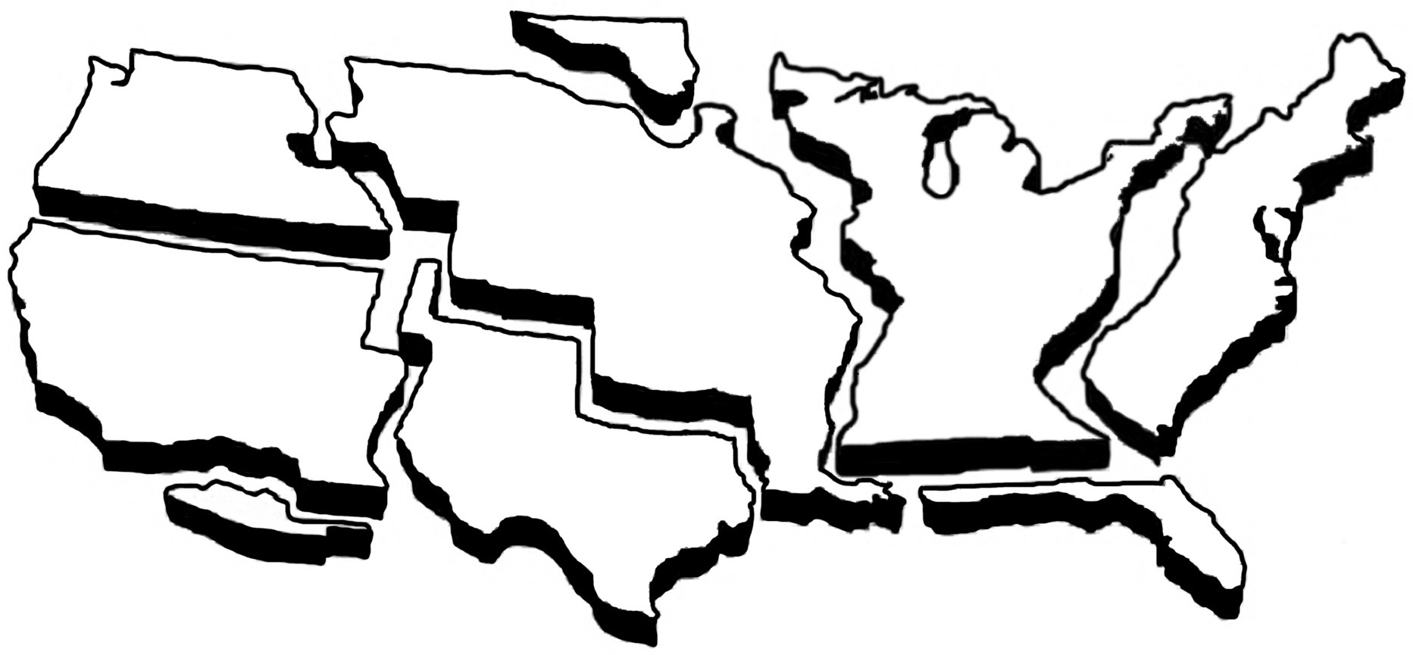

Year:

Who:

How:

Why:

Geographic features:

Sates located in the territory today:

Year:

Who:

How:

Why:

Geographic features:

Sates located in the territory today:

Year:

Who:

How:

Why:

Geographic features:

Sates located in the territory today:

Year:

Who:

How:

Why:

Geographic features:

Sates located in the territory today:

