Citing Sources

Go to [www.easybib.com](http://www.easybib.com)

Copy and paste, or type in your website used

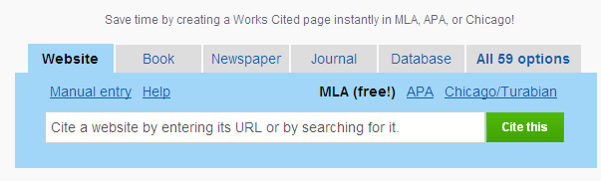

Example: History and Culture of Grand Canyon

Select the type of source

Copy and paste, or type in your website used

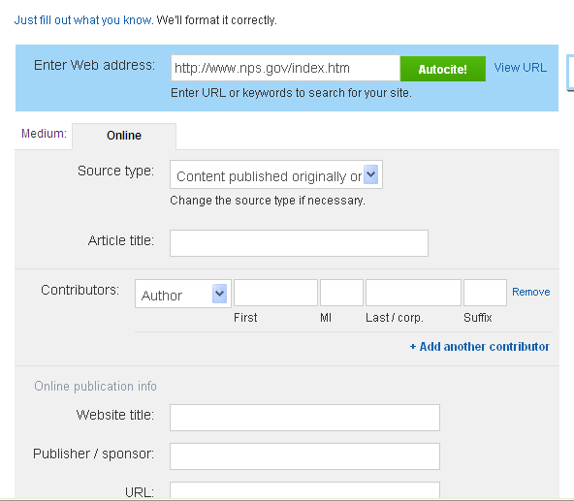

Example: U.S. National Parks is a title

Usually found at the bottom of an article or bottom of the main website.

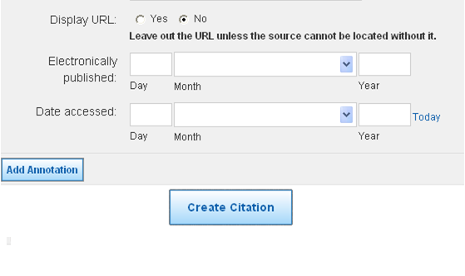

The date you found this information

Look for a date “last updated”