Creating a Constitution
- You must include the following in your Constitution:
- Preamble- introduction and “why” is there a need for a Constitution?
  - United States Preamble: “We the People of the United States, in Order to form a more perfect Union, establish Justice, insure domestic Tranquility, provide for the common defense, promote the general Welfare, and secure the Blessings of Liberty to ourselves and our Posterity, do ordain and establish this Constitution for the United States of America.”
- Bill of Rights (if any)
- Laws
Divide your Constitution into Articles. Use page 222 to see an example of how a constitution is written.
- How will the government be outlined? 3 branches? 1 branch?
- What is the power of the Central government?
- What power do states have?
- Who makes the laws?
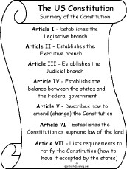
- Who has the power to tax, trade, declare war, and establish foreign relations?

