Creating a Constitution
- You must include the following in your Constitution:
- Preamble- introduction and “why” is there a need for a Constitution?
  - United States Preamble: “We the People of the United States, in Order to form a more perfect Union, establish Justice, insure domestic Tranquility, provide for the common defense, promote the general Welfare, and secure the Blessings of Liberty to ourselves and our Posterity, do ordain and establish this Constitution for the United States of America.”
- Bill of Rights 2-7
- Amendments 5-7
Divide your Constitution into Articles. Use page 222 to see an example of how a constitution is written.
- How will the government be outlined? 3 branches? 1 branch?
- What is the power of the Central government?
- What power do states have?
- Who makes the laws?
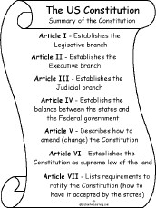
- Who has the power to tax, trade, declare war, and establish foreign relations?
Article I: Legislative- how are the laws made
Who makes war?
Article II: Executive- who has the power? What do they have the power to do?
Article III: Who judges? Who elects the judges? How many judges are there?
Article IV: States rights: Are the states equal? DO they have more power than the Central government? Do they have less power than the Central government
Article V: Military: How does the government get an army? How do they keep the army?

