Creating a Republic Unit Test Review

Include important Facts on your Hot DATE

**Compare and Contrast Articles of Confederation and Constitution- Complete the Venn Diagram with the words below.**

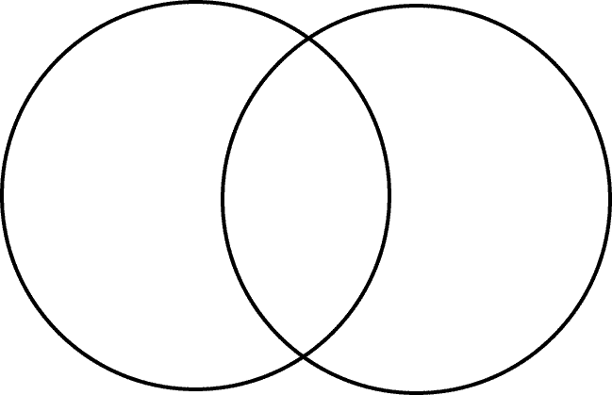 **Articles of Confederation BOTH Constitution**

Power to Declare War Strong Central government weak central government  
Power to Coin Money Created the Northwest Ordinance Has the power to regulate trade  
Power to Tax Had two Houses of Congress Only had a legislative branch  
Had a Supreme Court created the 3/5 Compromise Had one House of Congress  
Created during the American Revolution

Federalists and Anti-Federalists (Create a T-chart showing the differences of each group)

j0281710Articles of Confederation- (weaknesses and strengths)

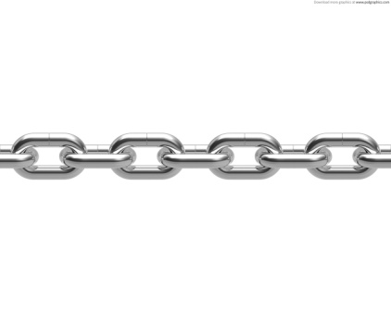

**Bill of Rights**

Why was it added to Constitution?

1st Amendment:

**Bundle of Compromises**

Virginia Plan-

New Jersey Plan-

Great Compromise-

3/5 Compromise

**Roots of the Constitution**

1. Magna Carta

2. Declaration of Independence:

3. Mayflower Compact:

**Founding Fathers & Enlightenment Thinkers**(significance during the Constitutional Convention)

1. **John Locke:**
2. **Thomas Jefferson:**
3. **Montesquieu:**
4. **George Washington:**
5. **James Madison:**

**Blast from the Past questions:**

Lexington and Concord:

Saratoga:

Yorktown:

**I understand that I have a test Friday, November 9, 2012. I will complete this review sheet, study, and be prepared for the exam. I studied for _________ minutes.**

**___________________ ____________________**

**Student Signature Parent Signature**