Define:
Abolitionist Movement:
Reform Movement:
Antebellum:

Reformers and Abolitionists: (write the significance/contributions of each)
1. Elizabeth Cady Stanton

2. Frederick Douglass

3. Harriet Tubman

4. Harriet Beecher Stowe

5. Susan B. Anthony

6. Lyman Beecher

7. Dorothea Dix

8. Sojourner Truth

9. Charles Grandison Finney

10. Horace Mann

Causes of the Civil War:
(write the significance and position of the North and South)
- Tariff Disputes

- State’s Rights

- Wilmot Proviso

- Dred Scott Decision

- Kansas-Nebraska Act

- Election of 1860

- Ft Sumter

Compromises- include the significance and impact of each
1. 3/5 Compromise

2. Missouri Compromise

3. Compromise of 1850

Significant Individuals
- Henry Clay

- Jefferson Davis

- Abraham Lincoln

- Robert E Lee
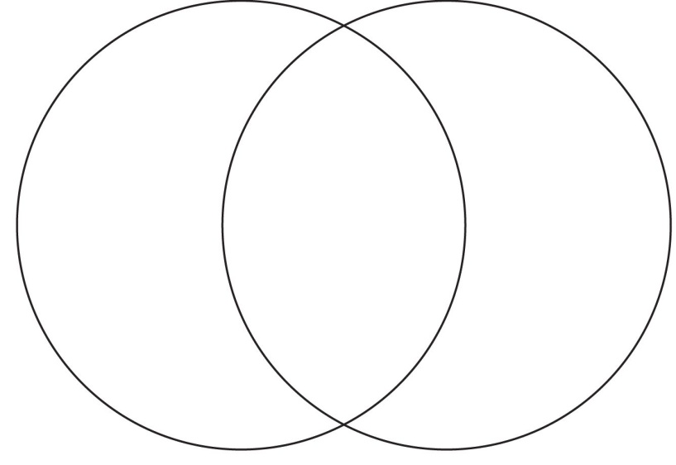

- Ulysses S Grant

Political Parties- include beliefs and regions
- Whig Party

- Democratic Party

- Free-soil Party

Create a t-chart depicting the advantages and disadvantages of the Union and Confederacy
Union Confederacy
Advantages: Advantages:

Disadvantages: Disadvantages

Goals of the North:

Goals of the South:

Complete the Venn Diagram depicting the similarities and differences between Lincoln and Davis’ Inaugural address

I understand that I have a U.S History test Thursday, March 28. I will complete my review sheet and be prepared for the test. My completed review sheet will count as a daily grade.

Student signature

Parent signature

