Below are 3 of our HOT DATES! Write the Who, What, Where, When and Why for each.

Articles of Confederation- (weaknesses and strengths)
Strengths | Weaknesses
Comparison Charts
Issue | Federalist | Democratic-Republican
Best Type of Government
Leader
Ideal Economy
Views on the Constitution

 | North/Union | South/Confederacy
Reasons for fighting
Adv/Disadv.

President

Military Leader
Surrender: Who surrendered to Whom and WHERE (name the place where the surrender took place)?

Significant People | Contributions/Significance
James Madison

Henry Clay

Frederick Douglass
Sojourner Truth

Dorothea Dix

Eli Whitney

Andrew Jackson

Lowell Girls

Frances Scott Key
Samuel Slater

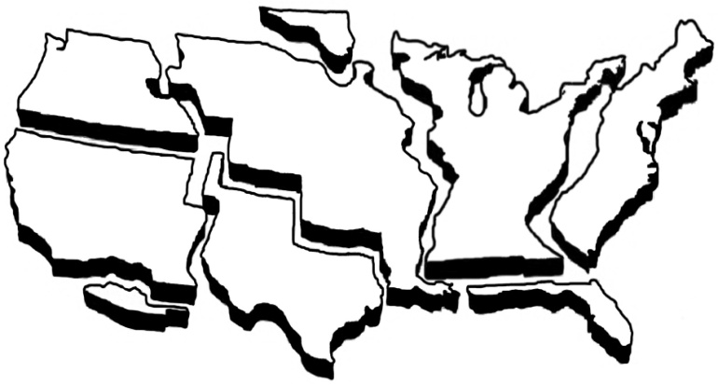
Manifest Destiny- Complete the map, include the date acquired, or any treaties.

Chapters 8 – The U. S. Constitution:
1. What was the second written government for the United States?
2. Who wrote the first ten amendments to the Constitution? Why were they ratified to the Constitution?
3. 7 Principles- define and describe each
1. Federalism-
2. Republicanism-
3. Popular Sovereignty-
4. Separation of Powers- (explain each branch)
5. Limited Government-
6. Checks and Balances
7. Individual Rights
4.Define
1. Veto
2. Amendment
3. elastic clause
4. impeach
5. What do we call the first 10 amendments to the Constitution?
6.What is the Supreme Law of the Land?
7. Identify the first amendment

Chapter 9- Washington and Adams:
1. What three things did Washington say in his Farewell Address?
2. What is the significance of the Whiskey Rebellion?
3. Define precedent
4. What is the significance of Jay’s Treaty?
5. Identify the following: Alien Act, Sedition Act, Naturalization Act
6. Explain the XYZ affair? Who were involved? Slogan?
Chapter 10 – Jefferson and Madison:
1. How much did Thomas Jefferson offer to pay for New Orleans and West Florida? What did Napoleon offer to sell to the U. S. and for what price? Why was Jefferson hesitant to purchase this vast amount of land?
2. What were the results of the U. S. purchasing this land area?
3. What is the significance of Marbury v Madison?
4. Define judicial review
5. What were the causes of the War of 1812?
6. Who led the Americans in the Battle of New
Orleans?
7. What ended the War of 1812? What were the terms?
8. What is the significance of the War Hawks?
Chapter 11 – Monroe and the Industrial Revolution:
1. Define Industrial Revolution.
2. Define interchangeable parts. Who was the inventor of interchangeable parts?
3. What was the Clermont? Who invented it?
4. In what industry were the first factories used?
5. Define Era of Good Feelings.
6. What is the significance of the Monroe Doctrine?
7. What is the significance of the Adams-Onis treaty?
Chapter 12 – The Jacksonian Era:
1. Define spoils system
2. Why did Jackson want to destroy the Bank of the U. S.? (4 reasons)
3. Define states' rights.
4. What was the significance of the Nullification Crisis?
5. Why did South Carolina threaten to secede during Jackson's term as president?
6. What was the Indian Removal Act? Define Trail of Tears.
Chapter 13 – Westward Expansion:
1. How was Texas added as a state?
2. Define manifest destiny.
3. What was the immediate cause of the Mexican War?
4. What were the parts of the Treaty of Guadalupe- Hidalgo? What war was ended by this treaty?
5. Who discovered gold in California?
6. Define Forty-Niners
7. What was the Gadsden Purchase?
Chapter 15 – Reform Movements and the New American Culture:
1. Define the following:
1. Temperance Movement
2. Abolitionist Movement
3. Suffrage
4. Civil disobedience
5. 2nd Great Awakening
2. Identify
1. Henry David Thoreau
2. William Lloyd Garrison
3. Susan B Anthony
4. Harriet Tubman
Chapter 16 – Causes of the Civil War:
Identify the following Compromises:
1. What were the three parts of the Missouri Compromise?
2. What were the 5 parts of the Compromise of 1850?
3. Who was considered the Great Compromiser?
Define the significance of the Causes:
4. Kansas-Nebraska Act
5. Secede
6. Election of 1860
7. Uncle Tom’s Cabin
8. John Brown’s Raid on Harper’s Ferry
9. Fort Sumter
10. Fugitive Slave Act
11. What country was formed by the seceding states?
12. Who were the President and Vice-President of the Union?
13. Who were the President and Vice-President of the Union?
Chapter 17 – the Civil War:
1. What was Lincoln's declared purpose for the war?
2. Goal of Lincoln’s 1st Inaugural address vs Goal of Davis’ 1st Inaugural address?
3. Identify the significance of the following battles:
1. Bull Run
2. Antietam
3. Gettysburg
4. Vicksburg
4. What was the name of the Union war strategy? What were the goals of the plan?
5. What were the goals of the Confederate war strategy?
6. Who led the famous "March to the Sea"?
7. Define Total War.
8. What did Lincoln's Emancipation Proclamation do?
9. Identify the goals of the Gettysburg Address.
10. Identify the significance of Appomattox Courthouse
Chapter 18 – Reconstruction:
1. Identify the 13th, 14th, and 15th Amendments.
2. What were the parts of the harsh Reconstruction Act passed by the Radical Republicans?
3. What President was put on trial for high crimes and misdemeanors? Was he found guilty and removed from office?
4. Define impeach
5. Define Freedmens Bureau.
6. Define Carpetbaggers.
7. Define Scalawags.
8. Define Ku Klux Klan.
9. Who assassinated Abraham Lincoln?
10. What was the purpose of the Freedman’s Bureau?
My final U.S. History semester exam is on ___________________________. I will complete my review and study to prepare myself for the exam.
_____________________
Student Signature
_____________________
Parent Signature

